# Solving the Murder Mystery

-Payal Karfa

Initial data related to the crime scene:

* Type: Murder​
* Date: Jan.15, 2018
* City: SQL City​

Names of the tables in the given database:

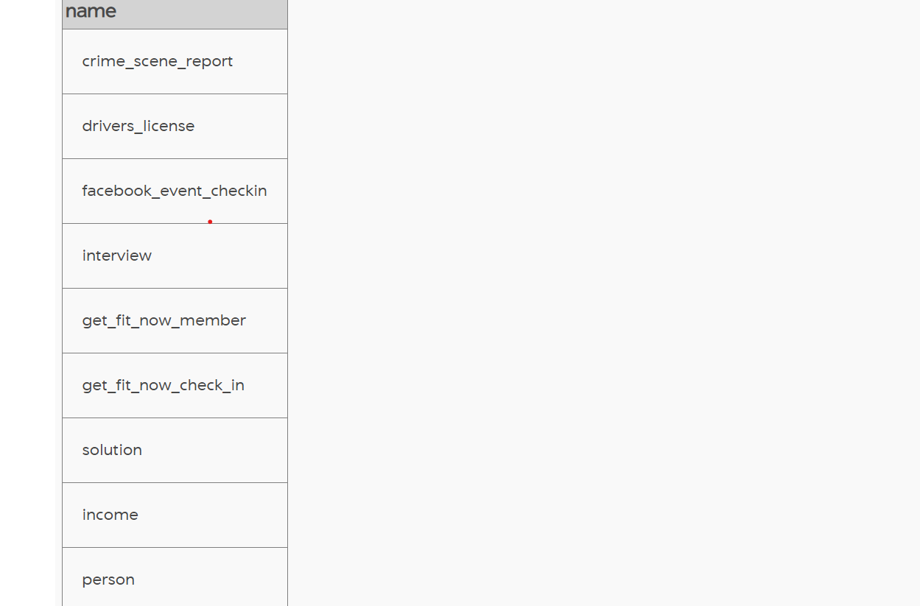 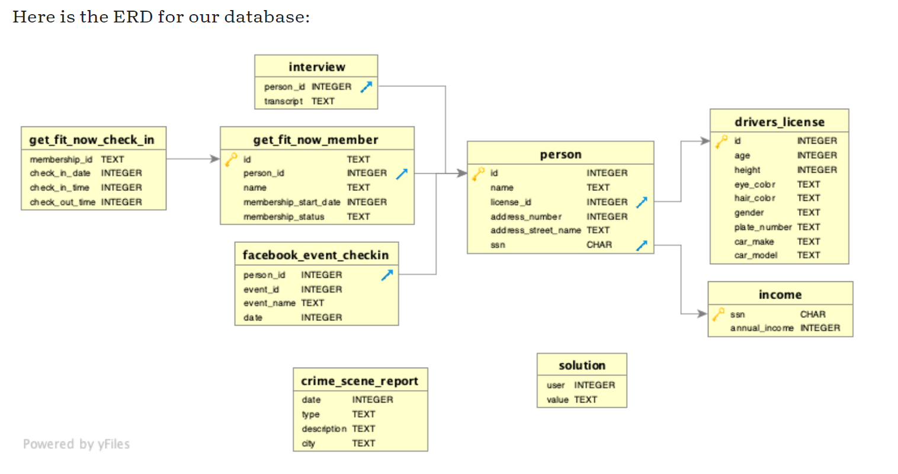

Structure of the `***crime_scene_report***` table

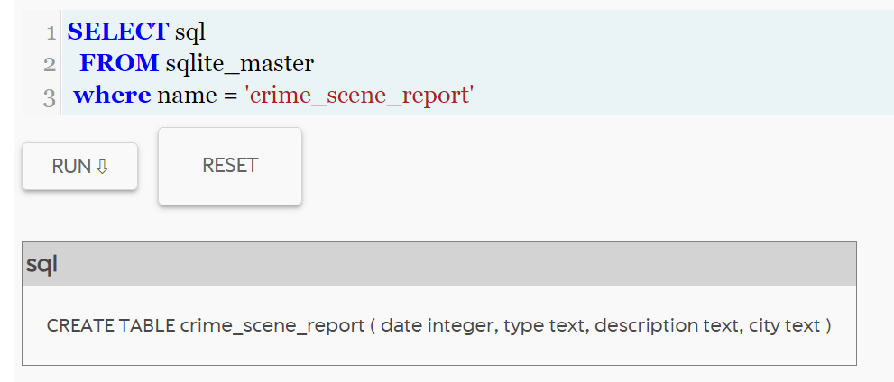

Using the given data,

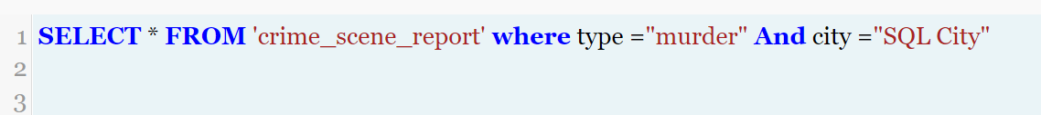

Results show the following,

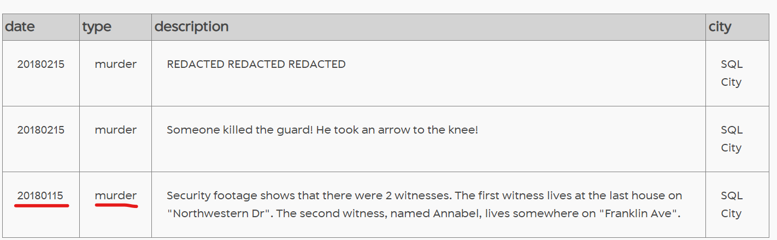

Finding the witnesses,

*Witness 1*

Last house number:

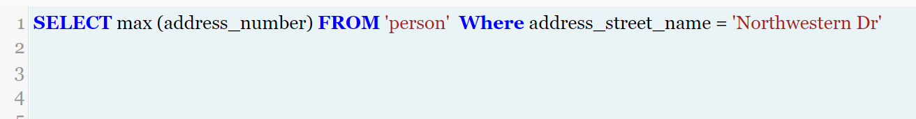

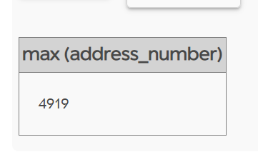

The witness from the last house:



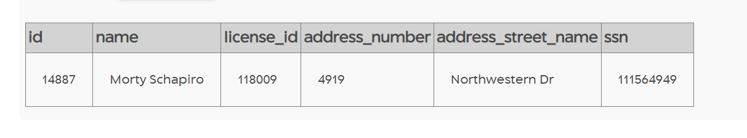

*Witness 2*

Annabel from Franklin Ave

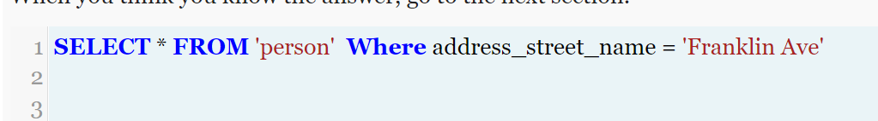

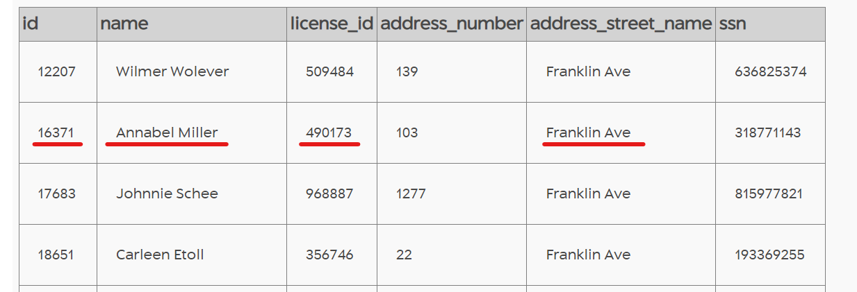

Morty’s interview,

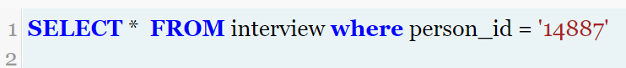

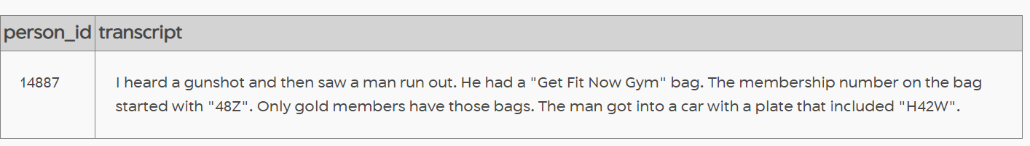

Annabel’s interview,



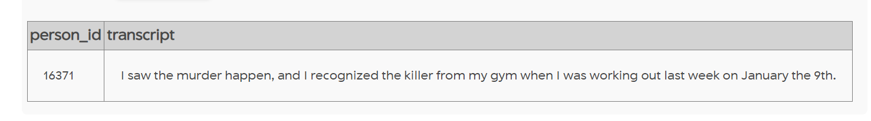

According to the descriptions given by the witnesses,



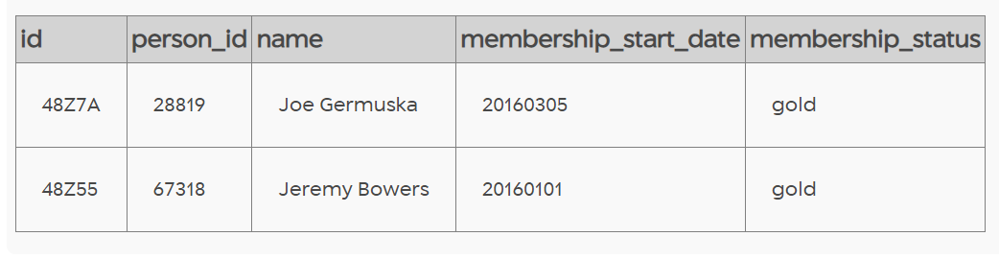

Finding the check-in date of the two people,

1. Joe



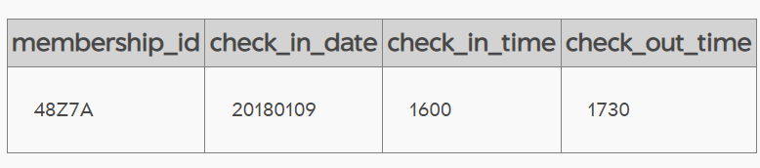

1. Jeremy



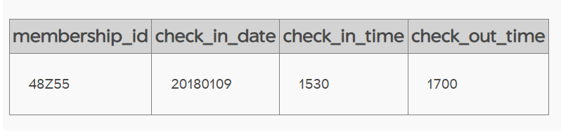

The check-in date is the same for the two. Finding the driver of the car,

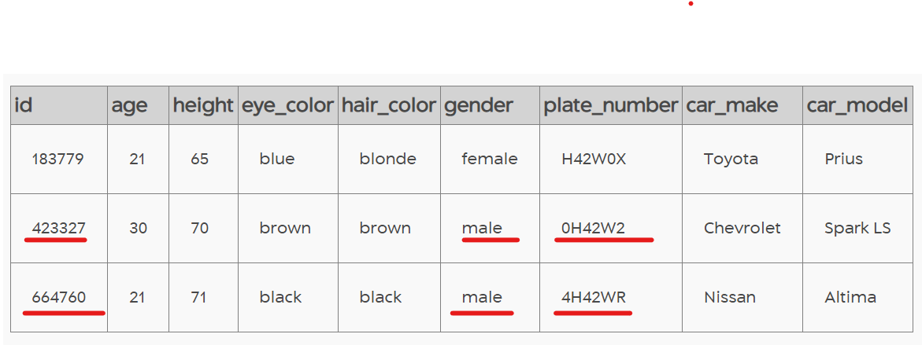



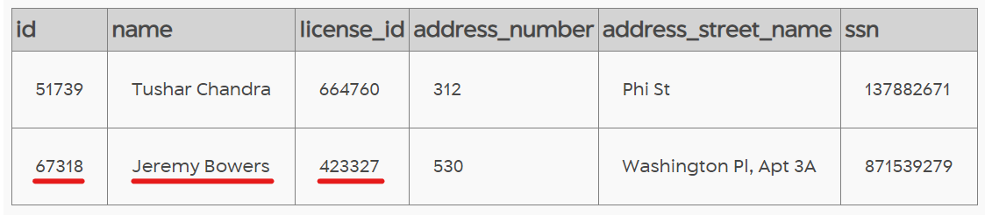

Found the murderer as Jeremy whose details match the witness's description.

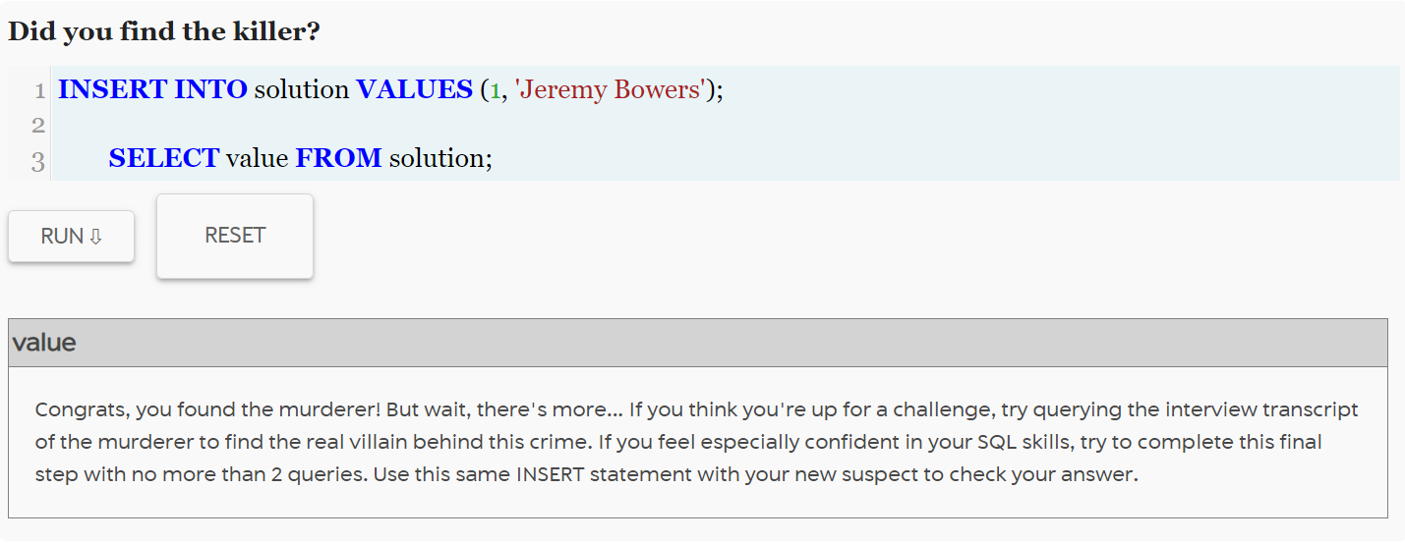

Interview transcript of Jeremy Bowers,



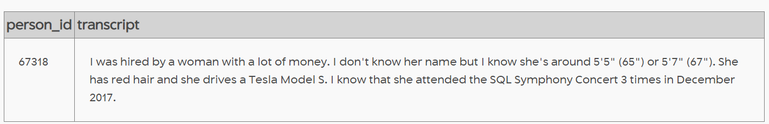

Finding the person as per Jeremy’s description,



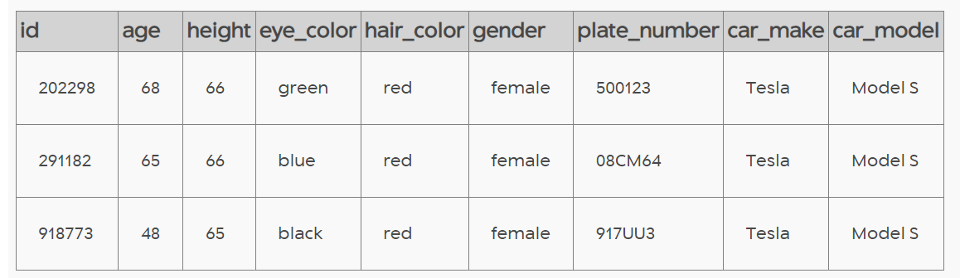



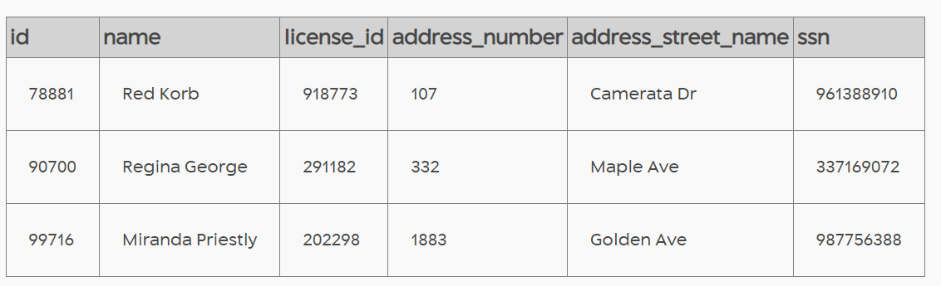



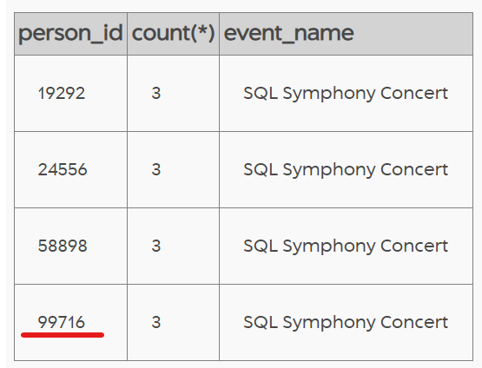

Thus, found the true mastermind behind the murder. It is Miranda Priestly.

